Nitrogen will be dispensed for Non-chemistry customers daily at 2PM.
Non-chemistry customers wishing to purchase liquid nitrogen must be preauthorized. There are three options:
- Frequent users can request to have a dispensing fob issued. Contact Tony Mittertreiner to arrange for a fob to be created for your group.
- Go to Chemistry Stores and ask to purchase liquid nitrogen. They will process the transaction and provide you with a printed receipt. Give the printed receipt to the dispensing technician. Stores is open between 10 and 11AM, and 2 and 3 PM.
- Order N2 in PlanOn at least one day prior to coming to get N2. Instructions for using PlanOn can be found on the Chemistry department website: Search for “UBC Chemistry Stores Product Store.PDF” in google and you should be directed to the document “STO 124” that shows how to use Plan On.
  - Liquid nitrogen can be found under Chemicals Compressed Gasses
  - The screen below is an example of what you want to get to when ordering N2.
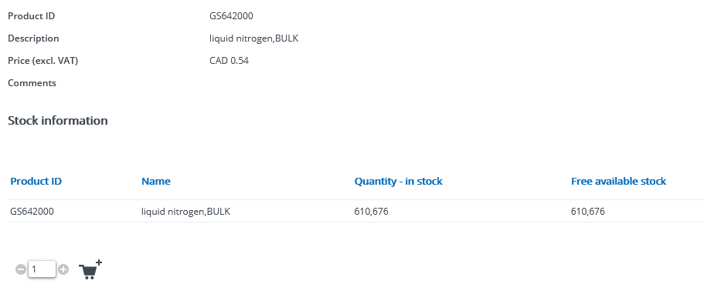
  - After you place the order, it will be processed automatically by stores, and you will receive an email within 1 working day advising that your product is ready for pickup.
  - Bring a copy of the email to give to the dispensing technician.
  - You will not need to go to stores if you use this method.

Contacts:
Technicians (Chemistry Mechanical Shop): 604-822-9467
Billing issues (Tony Mittertreiner) 604-817-6363 tonym@chem.ub.ca
Stores 604-822-3865 storz@chem.ubc.ca

